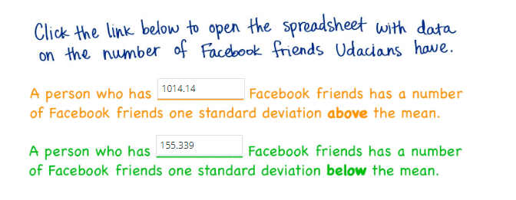

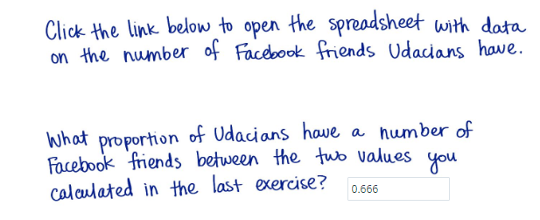

Source: <https://docs.google.com/spreadsheets/d/1FPd4ULNP7QxE619keCO7bQiPOFUzAQCnT3kpVOm3mig/edit#gid=0>

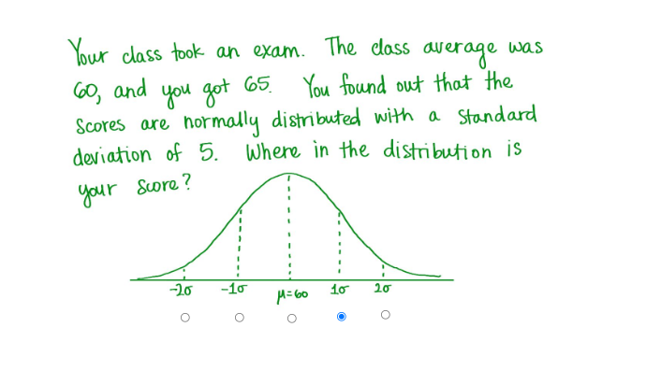

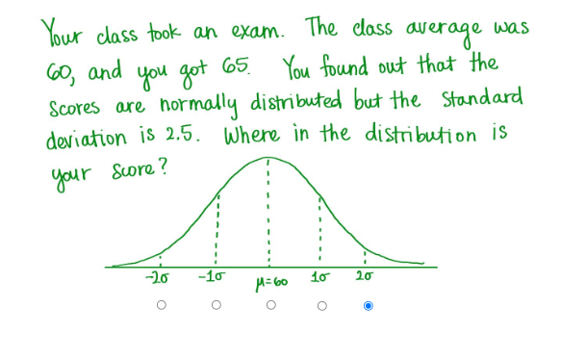

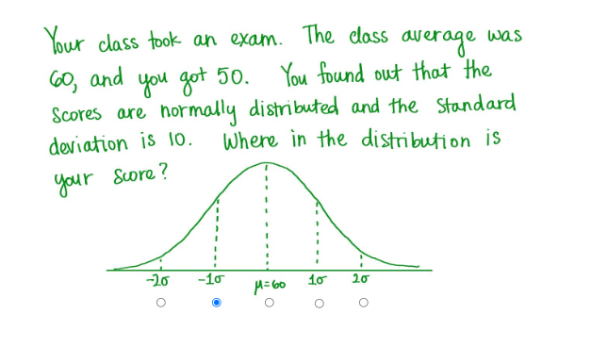

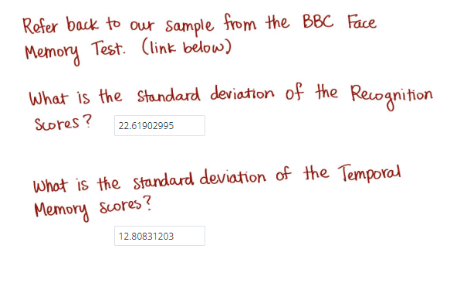

Source: <https://docs.google.com/spreadsheets/d/1b_Efze7HAOEooyiiUbTg4Fih-EleFStT8boFglvkZdk/edit#gid=0>

